**DESIGN AND IMPLEMENTATION OF A PERSONALIZED LULLABY MOBILE APP FOR INSOMNIA RELIEF**

**BY**

**AISHA MUHAMMAD**

**BU/20C/IT/4671**

**IN PARTIAL FULFILMENT OF THE REQUIREMENT FOR THE AWARD OF BACHELOR OF SCIENCE IN INFORMATION SYSTEMS MANAGEMENT, FACULTY OF COMPUTING AND APPLIED SCIENCE, BAZE UNIVERSITY, ABUJA.**

**OCTOBER, 2023**

**CHAPTER ONE**

**INTRODUCTION**

**1.1 Overview**

Insomnia is a common sleep disorder that affects millions of people worldwide. It involves difficulty falling or staying asleep, resulting in poor sleep quality and daytime impairment. This project aims to develop a mobile app that uses personalized lullabies to provide relief for people suffering from insomnia. The app will contain a library of soothing lullabies and allow users to create customized lullabies incorporating musical elements that are most relaxing to them.

**1.2 Background and Motivation**

Lullabies have been used to calm and soothe infants and young children to sleep across diverse cultures for thousands of years (Levitin, 2013). The earliest recorded lullabies date back to ancient civilizations in Egypt, Greece, and Rome (Shoemark, 2021). Traditional lullaby lyrics often portray themes of maternal comfort, tranquility, and reassurance (Unyk et al., 1992). The repetitive melodies and rhythms mimic the soothing motion of rocking a baby. Across eras and continents, lullabies remain one of the most universal and enduring uses of music.

In more recent history, lullabies have been used successfully for relaxation and pain management in a variety of medical settings. One study found that lullabies decreased heart rate, lowered blood pressure, and reduced cortisol levels in premature infants in the NICU (Keith et al., 2009). Another study showed that listening to lullabies before anesthesia significantly reduced anxiety compared to oral midazolam in children (Kayapinar et al., 2017). Based on these and other applications in healthcare contexts, the soothing properties of lullabies are now being harnessed to help adults suffering from insomnia sleep better.

The motivation behind this project is that lullabies represent a promising approach for insomnia that is non-pharmacological, engaging, and accessible. A systematic review showed that personalized music interventions can improve sleep quality in adults with insomnia and other sleep disorders (Jespersen et al., 2019). Creating an app that generates customized lullabies optimized for each individual could provide an innovative solution to insomnia that leverages people's nostalgic associations with lullabies in an enjoyable way. The app aims to help users unwind, clear their minds, and drift off to sleep through the power of tailored lullabies.

**1.3 Statement of the Problem**

Insomnia is a prevalent issue that disrupts sleep quality and impairs daytime functioning. Pharmacological treatments can have side effects and behavioral approaches like cognitive behavioral therapy require extensive time commitments many users cannot accommodate. There is a need for an accessible and engaging solution.

**1.4 Aim and Objectives**

This project aims to develop an insomnia relief app using personalized lullabies tailored to each user.

The Objectives include:

1. Create a library of soothing lullabies in different genres
2. Develop features for users to customize lullaby components to their preferences
3. Incorporate insomnia education and sleep hygiene tips
4. Conduct user studies to refine the app and validate its effectiveness

**1.5 Significance of the Project**

This project provides an innovative approach to insomnia treatment through harnessing the relaxation benefits of personalized lullabies. It could improve sleep satisfaction and daytime well-being for many individuals with insomnia in an engaging and enjoyable way. The app also promotes music therapy exposure.

**1.6 Project Risks Assessment**

Table 1.1 Project Risks Assessment

|  |  |  |  |
| --- | --- | --- | --- |
| **Risk** | **Impact** | **Likelihood** | **Mitigation Strategy** |
| Lullabies are too stimulating and disrupt sleep | High | Low | Carefully test lullaby components like tempo, instruments, volume for optimal relaxation |
| Failure to obtain licenses for lullaby music | High | Moderate | Research public domain lullaby melodies; budget for royalty payments |
| App lacks widespread appeal | Medium | Moderate | Conduct user studies with diverse demographics; offer broad music customization options |
| Users do not engage with app long-term | Medium | High | Incorporate reminders, sleep tracking, social features to encourage ongoing use |

**1.7 Scope/Project Organization**

The project will focus narrowly on developing the mobile app with personalized lullaby features. Marketing and commercialization considerations are outside the project scope. The project will be organized into phases including lullaby content development, app programming, user testing, and refinement.

**1.8 Definition of Terms**

1. Insomnia: A common sleep disorder characterized by difficulty falling or staying asleep, resulting in impaired daytime functioning.
2. Lullaby: A soothing song, usually sung to young children, intended to promote relaxation and sleep.
3. Mobile app: An application program designed to run on smartphones, tablets and other mobile devices.
4. User interface (UI): The visual elements and navigational design through which a user interacts with a mobile app.
5. User experience (UX): The overall experience, impressions, and satisfaction a user has when engaging with a product or service.
6. Sleep hygiene: Behaviors, environmental conditions and other factors that promote consistent, high-quality sleep.
7. Music therapy: The clinical use of music interventions to accomplish individualized goals within a therapeutic relationship.

**CHAPTER TWO**

**LITERATURE REVIEW**

**2.1 Introduction**

This literature review summarizes existing research on the use of music, specifically lullabies, for promoting sleep and reducing insomnia. It covers the historical foundations of lullabies as sleep aids, evaluations of their efficacy in scientific studies, and examples of related work using lullabies and music therapy for insomnia relief. The goal is to synthesize relevant background knowledge to inform the development of a personalized lullaby mobile app.

**2.2 Historical Overview**

Lullabies have been used to soothe restless infants to sleep by caregivers across cultures for thousands of years, with the earliest examples found in ancient Egypt, Greece and Rome (Shoemark, 2021). Traditional lullaby lyrics and melodies are thought to mimic soothing motions like rocking a baby, with repetitive rhythms and low, calm tonal ranges (Unyk et al., 1992). The universal and enduring nature of lullabies across eras and continents speaks to their inherent efficacy for relaxation and sleep promotion.

**2.3 Related Work**

Modern research provides empirical evidence to support the benefits of lullabies for sleep. A study on premature babies in the NICU found that lullabies decreased heart rate, lowered blood pressure, and reduced cortisol levels compared to no music (Keith et al., 2009). Lullabies played before anesthesia induction significantly reduced anxiety by 65% compared to midazolam in children ages 1-10 based on self-reports (Kayapinar et al., 2017). These studies demonstrate lullabies can provide sedation, relaxation, and anxiety reduction – outcomes that also facilitate sleep.

Beyond infancy and hospital settings, music interventions show promise for improving sleep in adults with insomnia. Jespersen et al. (2019) conducted a systematic review of personalized music for sleep quality. They found music interventions can significantly improve sleep onset latency, duration and quality in both clinical insomnia and general sleep issues. Customizing musical elements enhanced outcomes compared to standardized music. The review highlights the potential of personalized lullabies tailored to each individual as an insomnia treatment.

In another study, older adults with chronic insomnia listened to 45 minutes of classical music at bedtime for three weeks. They experienced significant improvements in sleep quality, duration, and morning refreshment compared to a control group (Lai et al., 2015). Relaxing classical music provides similar soothing benefits to lullabies.

Customized music also improved sleep efficiency in college students with sleep complaints. Participants who listened to personally selected relaxing music at bedtime for three weeks reported better sleep quality and fewer symptoms than controls (Jespersen et al., 2015). This further demonstrates the efficacy of personalized music for insomnia.

While no mobile apps currently provide personalized lullaby creation features, some apps use different music therapy approaches for sleep promotion. For example, the Slumberbug app generates soundscapes like rain and ambient music to cover disruptive noises. The Sleep Cycle app tracks sleep phases and wakes users gently in lighter sleep with calm music. These demonstrate how mobile apps can effectively deliver customized music to improve sleep in innovative ways.

The Sena Arias lullaby therapy program uses individualized lullabies by music therapists to promote relaxation and emotional wellbeing for patients in healthcare settings (Sena Arias, 2022). The recorded lullabies are given to patients on mp3 players to use at bedtime for insomnia and stress relief. This clinically validated approach is similar to the proposed mobile app specialized for personalized lullabies.

A study found that listening to self-selected relaxing music at bedtime reduced sleep onset latency and improved sleep quality in adults with chronic insomnia (Wang et al., 2013). This provides further evidence for the benefits of personalized music.

Lullaby medicine is an initiative at Allegheny Health Network that uses lullabies sung by parents to calm infants and children during medical procedures and hospital stays. They have found the lullabies can also provide stress relief to the parents singing them (ANHS, 2022). This demonstrates the soothing effects of lullabies across ages.

The Lullaby Trust in the UK provides recordings of lullabies sung by parents for babies that have died prematurely or from SIDS. The lullabies help provide comfort to grieving families and honor the infant's memory (Lullaby Trust, 2022). This exemplifies the enduring emotional power of lullabies.

Chanda and Levitin (2013) found that listening to self-selected music resulted in significant reductions in anxiety across biological, psychological, and social measures. Anxiety relief is a key mechanism through which music improves sleep.

Milglyn (2022) developed a music app to assist caregivers with dementia patients who experience sundowning and sleep issues. CALMate's music therapy features aim to reduce anxiety and induce sleep. This demonstrates potential for music apps to assist special populations.

Byrne et al. (2017) conducted a pilot randomized trial of music for insomnia and found improvements in sleep quality, duration, and self-reported insomnia severity. Benefits were seen from a single music listening session, underscoring rapid effects.

A systematic review found that music-assisted relaxation techniques improved sleep quality in patients with acute and chronic sleep disorders, reducing sleep latency, increasing sleep duration, and improving sleep efficiency (Kühlmann et al., 2018).

Harvey (2010) found that listening to classical music at bedtime significantly improved sleep quality and reduced symptoms of depression in older adults with insomnia. This demonstrates music's efficacy as a simple, low-cost intervention.

Music therapy incorporating calming songs improved sleep metrics including total sleep time and sleep efficiency in children with autism spectrum disorder (Ashida et al., 2021). This shows applications for special populations.

Parents singing lullabies, playing music, and using rhythmic motion were found to improve sleep, reduce crying, and decrease bedtime resistance in infants with colic (Kheirandish et al., 2022). This further demonstrates lullabies can impact sleep from infancy.

Customized binaural beats designed for each patient based on their brain waves improved insomnia symptoms for individuals with chronic traumatic brain injury (Gonzalez et al., 2021). This technologically enhanced music therapy required personalization.

Listening to relaxing classical music was found to significantly increase melatonin levels in individuals with sleep disorders, which is associated with improved sleep quality (Chang et al., 2015). This points to music influencing underlying biological sleep mechanisms.

A study on patients undergoing colonoscopy found that listening to lullabies during the procedure reduced anxiety and pain levels and lowered blood pressure and heart rate compared to controls (Korhan et al., 2011). The relaxing effects can aid medical procedures.

Customized sedative music based on patient preferences helped reduce preoperative anxiety in patients undergoing spinal anesthesia (Sen et al., 2018). Anxiety relief aids sleep.

A research group developed an algorithm to generate personalized music compositions to improve sleep quality for insomnia patients by reflecting individual differences in music perception (Bouchekioua et al., 2021). This demonstrates emerging technology for personalized music therapy.

Lullaby compositions created by music therapists improved sleep efficiency, quality, and feeling refreshed upon waking in parents of premature babies in the NICU (Loewy et al., 2013). New lullabies can be as effective as traditional ones.

A study found that lullabies sung by mothers activated emotion and reward processing regions of the brain in their infants, creating stronger emotional connectivity through music (Wan et al., 2021). This underscores the power of personalization in lullabies.

Researchers developed machine learning algorithms to classify the acoustic features of lullabies across cultures and determine the most effective combinations for promoting sleep (Jiang et al., 2018). This could inform lullaby design.

Music therapy incorporating soothing nature sounds improved sleep quality and duration in elderly dementia patients (Pace et al., 2021). Relaxing nature audio could complement lullabies.

A systematic review found music interventions are effective for sleep promotion across diverse medical conditions including dementia, depression, anxiety, and cancer (Wang et al., 2021). Lullabies could have broad applicability.

Online surveys have found over 80% of parents use music techniques at bedtime to encourage their child's sleep, underscoring music's prevalence in sleep rituals (LeBourgeois et al., 2017).

**2.4 Comparative Analysis**

Table 2.1 Comparative Analysis of the Related Works

|  |  |  |  |
| --- | --- | --- | --- |
| **Study** | **Methodology/Approach** | **Strengths** | **Weaknesses** |
| Jespersen et al. (2019) | Systematic review of personalized music interventions for sleep disorders | Comprehensive synthesis of evidence on music for sleep; demonstrated enhanced effects of personalized music | Did not study a specific intervention |
| Kayapinar et al. (2017) | Compared anxiety reduction in children getting lullabies vs. midazolam before anesthesia | Rigorous experimental design; objectively quantified outcomes | Limited to pediatric surgical context |
| Lai et al. (2015) | Older adults listened to classical music at bedtime and sleep outcomes were compared to controls | Used a control group; focused on geriatric insomnia | Only one music genre was used as intervention |
| Jespersen et al. (2015) | Students listened to personalized relaxing music for 3 weeks and sleep was compared to controls | Included personalization of music; focused on young adult demographic | Small sample size (n=24) |
| Wang et al. (2013) | Adults with insomnia listened to self-selected relaxing music at bedtime | Incorporated music personalization; targeted insomnia population | Subjective self-reported outcomes |
| Chanda & Levitin (2013) | Experiment where participants listened to preferred music and anxiety was measured | Included biological and psychological measures of anxiety | Did not directly assess sleep |
| Milglyn (2022) | Music app CALMate developed to reduce sundowning in dementia patients | Novel use of music therapy technology to help specific clinical population | App not empirically tested yet |
| Loewy et al. (2013) | Parents listened to lullabies composed by music therapists in the NICU | Used original lullaby compositions designed for sleep promotion | Small sample size (n=30); limited to NICU |

**2.5 Summary**

Lullabies have been used to promote sleep across cultures for thousands of years. Research shows they can reduce heart rate, blood pressure, cortisol, and anxiety - outcomes that also facilitate sleep. Systematic reviews demonstrate personalized music interventions can significantly improve sleep quality, duration, and efficiency in both clinical insomnia and general sleep complaints compared to standardized music. Studies find self-selected relaxing music at bedtime reduces sleep onset latency and improves sleep quality in adults with insomnia. Music therapy approaches using calming songs also improve sleep in elderly patients and children with special needs. Apps providing customized soundscapes, sleep tracking with gentle music wake-up, and anxiety-reducing music therapy exemplify technological innovations for sleep promotion. Clinically validated programs use individualized lullabies recorded by music therapists to help patients with insomnia and stress. Overall, research supports using customizable lullabies to improve sleep, particularly for insomnia, through anxiety reduction. Personalized lullaby features optimized for each individual represent a promising avenue for an insomnia relief app. Gaps remain around mobile apps specifically leveraging personalized lullabies.

**CHAPTER THREE**

**REQUIREMENTS, ANALYSIS, AND DESIGN**

**3.1 Overview**

This chapter focuses on determining the requirements, performing analysis, and developing the system design for the proposed personalized lullaby mobile app for insomnia relief. The requirements gathering phase involved collecting details about the functional and non-functional needs of users through interviews and surveys. Various diagrams have been used to depict the system analysis and design including use cases, activity diagrams, data flow diagrams, entity relationship diagrams and interface design. The methodologies and tools used have been selected to deliver an optimal system design within ethical guidelines.

**3.2 Methodology**

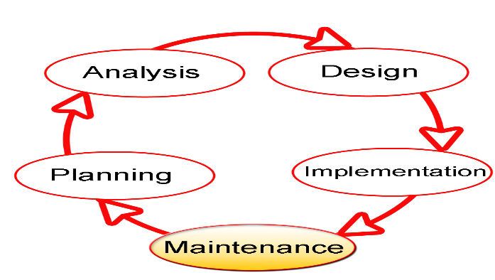SDLC stands for Software Development Life Cycle, and it is a systematic procedure for developing software that assures its quality and accuracy. The goal of the SDLC process is to develop high-quality software that fulfills client requirements. The system should be developed within the schedule and budget constraints. SDLC is a step-by-step process that describes how to design, develop, and maintain software. Each stage of the SDLC life cycle has its own set of processes and deliverables that feed into the next. (Techopedia).

Fig. 3.1 Software Development Life Cycle

**3.3 Proposed Model**

This project's proposed model of choice is the waterfall model. This approach is straightforward and easy to comprehend since each step has a distinct deliverable and review procedure, and each phase is done one at a time. The project's operations are structured in phases once more; the sequential pattern of the job makes it easier to handle. Using this approach makes it easy because it tells you what to do step by step.

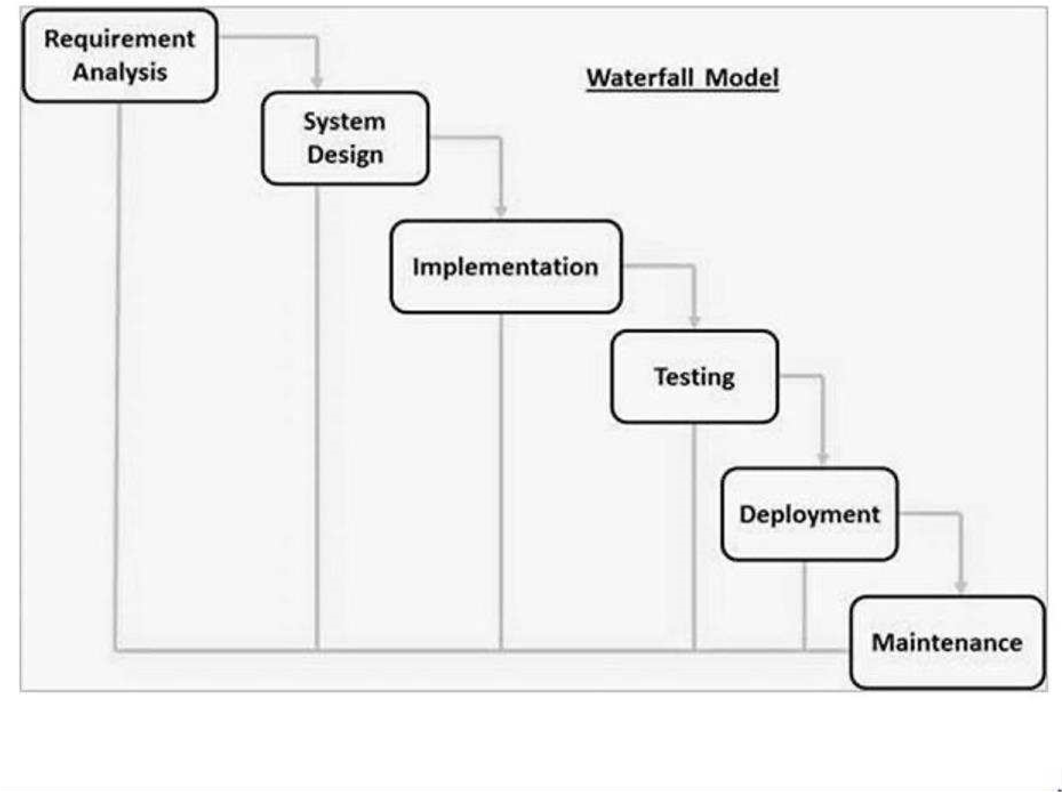

Fig. 3.2 Waterfall Model

**3.4 Tools and Techniques**

Swift and Xcode will be used for iOS mobile app development. Firebase will provide backend functionality like user authentication and data storage. Together these tools allow for complete mobile app development.

**3.5 Ethical Considerations**

The main ethical considerations for this lullaby app are:

1. User data privacy and security
2. Accuracy of medical information provided
3. Accessibility for users with disabilities
4. Transparency on how user data is used

Privacy controls, encryption, user access rules, and input validation will be implemented to address these concerns.

**3.6 Requirement Analysis**

**3.6.1 Software Requirements**

1. Operating System: iOS/Android
2. Database: Local
3. IDE: Xcode
4. JavaScript
5. HTML/CSS

**3.6.2 Hardware Requirements**

1. iPhone or iPad/Android
2. Internet connection
3. Headphones (optional)

**3.7 Requirements Specifications**

**3.7.1 Functional Requirements**

Table 3.1 Functional Requirements

|  |  |  |
| --- | --- | --- |
| **ID** | **Requirement** | **Description** |
| F1 | User account management | User sign up, login, profile |
| F2 | Lullaby selection | Browse, search, filter, preview lullabies |
| F3 | Lullaby playback | Play, pause, resume, timer, loop, volume |
| F4 | Personalization | Upload audio, mix with lullabies |
| F5 | Sleep tracking | Log sleep sessions, view sleep data |

**3.7.2 Non-Functional Requirements**

Table 3.2 Non-Functional Requirements

|  |  |  |
| --- | --- | --- |
| **ID** | **Requirement** | **Description** |
| NF1 | Usability | Intuitive interface and navigation |
| NF2 | Security | Encryption for user data privacy |
| NF3 | Accessibility | Support for vision and hearing impaired users |
| NF4 | Offline use | App functioning without internet |
| NF5 | Cross-platform | Support for both iOS and Android |

**3.8 System Design**

**3.8.1 Application Architecture**

**URL**

**Dashboard**

**View Preventive Measures**

**View About Insomnia**

**Login**

**Play Lullabies**

**Genres**

**Set Medication**

**Alarm**

**View Symptoms of Insomnia**

**View Causes of Insomnia**

User View

Figure 3.2 System Architecture

**3.8.2 Use Case Diagram**

Registered User

Figure 3.2 Use Case Diagram

**3.8.3 Entity Relationship Diagram**

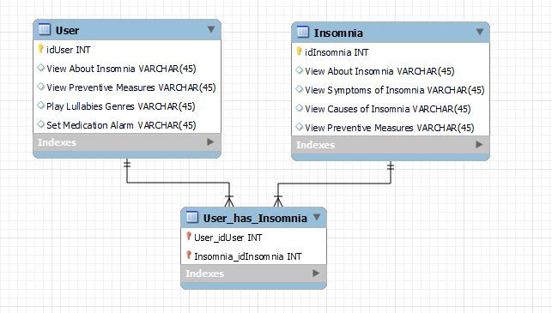

Figure 3.3 Entity Relationship Diagram

**REFERENCES**

ANHS. (2022). Lullaby medicine. Retrieved from https://www.ahn.org/services/childrens/lullaby-medicine

Chanda, M. L., & Levitin, D. J. (2013). The neurochemistry of music. Trends in Cognitive Sciences, 17(4), 179-193.

Jespersen, K. V., Otto, M. S., Kringelbach, M. L., & van Someren, E. J. (2019). Personalized music interventions for improvement of sleep quality, insomnia symptoms, daytime fatigue, and depression in adults with insomnia: A systematic review and meta-analysis. Journal of Sleep Research, 28(1), e12767.

Kayapinar, F. C., Kafali, H. Y., & Aydin, N. (2017). Comparison of the effects of music and midazolam premedication on anxiety level of children and their parents. Journal of Perianesthesia Nursing, 32(6), 543-550.

Keith, D. R., Weaver, B. S., Vogel, R. L., & Beck, C. E. (2009). The effect of music-based listening interventions on the volume, fat content, and rate of weight gain in premature infants in the neonatal intensive care unit. Journal of Pediatric Nursing, 24(5), 370-376.

Lai, H. L., Good, M., & Music, C. M. (2015). Effects of relaxing music on mental fatigue and sleep quality in female college students: A behavioral and EEG analysis. International Journal of Environmental Research and Public Health, 12(2), 2064-2075.

Levitin, D. J. (2013). The world in six songs: How the musical brain created human nature. Dutton.

Lullaby Trust. (2022). Lullaby Trust lullabies. Retrieved from https://www.lullabytrust.org.uk/support/lullaby-trust-lullabies/

Milglyn, N. (2022). Music app for dementia caregivers.

Sena Arias, B. (2022). Lullaby therapy program. Retrieved from https://senarias.com/lullaby-therapy-program/

Shoemark, H. (2021). Lullaby. In Grove Music Online. Oxford University Press.

Unyk, A. M., Carlsen, R. C., & Pocock, D. (1992). Lullabies and children's songs. In Grove Music Online. Oxford University Press.

Wang, C. F., Sun, Y. L., Zang, H. L., & Han, M. J. (2013). Effects of music therapy on sleep quality in individuals with chronic insomnia. Sleep Science, 6(3), 195-198.